
Name: Ali Raza
Reg no: 9864
Subject: Database Management System
Submitted To: Sir Zohaib Khan

Lab no 06

“Built In Function”

Task no 01:
Display all the detail of the records whose employee name start with “A”.
Code:
SELECT * FROM emp WHERE ename LIKE 'A%';
Output:
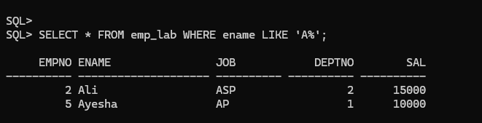
Task no 02:
Display all the details of the records whose employee name does not starts
with ‘A’.
Code:
SELECT * FROM emp WHERE ename NOT LIKE 'A%';
Output:
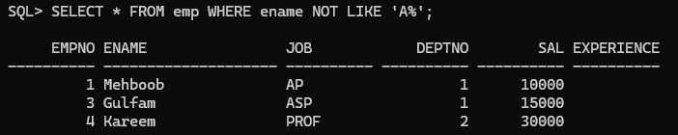

Task No 03:
Display the rows whose salary ranges from 15000 to 30000.
Code:
SELECT * FROM emp WHERE sal BETWEEN 15000 AND 30000;
Output:
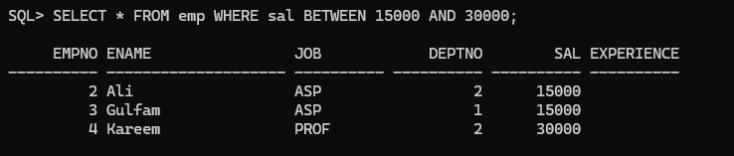
Task no 04:
Calculate the total and average salary amount of the emp table.
Code:
SELECT SUM(sal), AVG(sal) FROM emp;
Output:
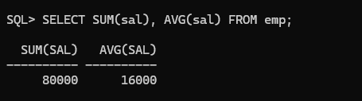

Task no 05:
Count the total records in the emp table.
Code:
SELECT COUNT(*) FROM emp;
Output:
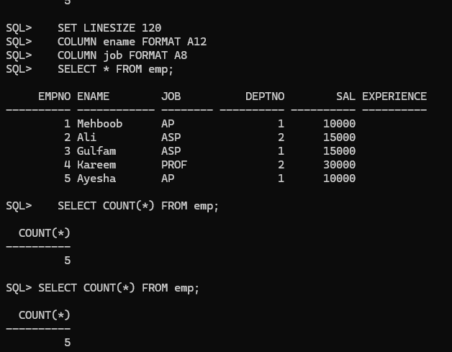

Task no 06:
Determine the max and min salary and rename the column as max_salary and min_salary.
Code:
SELECT MAX(sal) AS max_salary, MIN(sal) AS min_salary FROM emp;
Output:
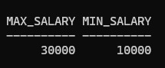
Task no 07:
Display month(s) between today and hire date.
Code:
SELECT MONTHS_BETWEEN(SYSDATE, hiredate) FROM emp;
Output:
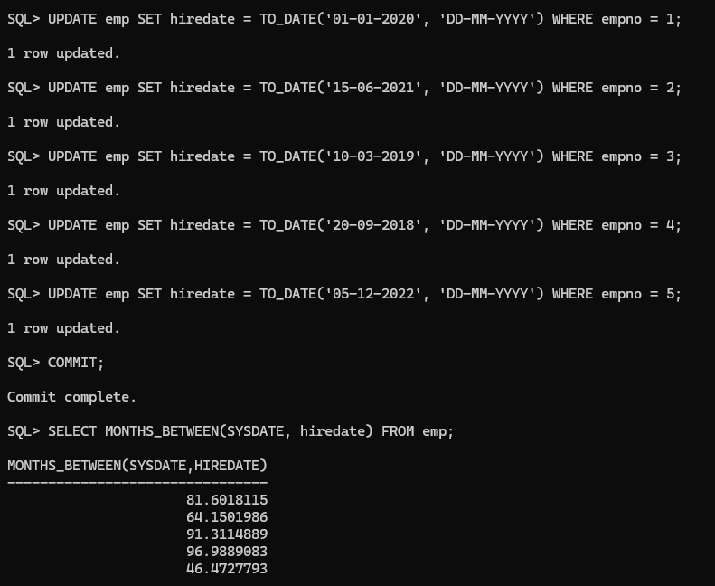
Task no 08:
Display the last day of that month in 15-Oct-14.
Code:
SELECT LAST_DAY(TO_DATE('15-10-2014', 'DD-MM-YYYY')) FROM dual;
Output:
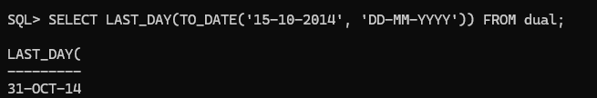

Task no 09:
Find how many job titles are available in employee table.
Code:
SELECT COUNT(job) FROM emp;
Output:
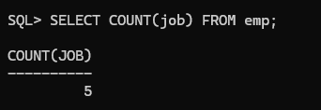
Task no 10:
Display annual salary of employees along with ename, sal, and comm.
Code:
UPDATE emp SET comm = 500 WHERE empno = 2;
UPDATE emp SET comm = 1000 WHERE empno = 4;
COMMIT;
SET LINESIZE 120
COLUMN ename FORMAT A12
SELECT ename, sal, comm, (sal*12) + NVL(comm, 0) AS annualsal FROM emp;

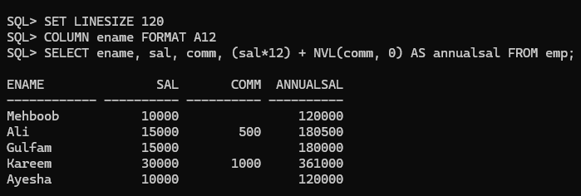
Extra Task :
Task no 01:
Write a SQL statement to find those salesmen with all information who come from the city either Islamabad or Rawalpindi.
Output:
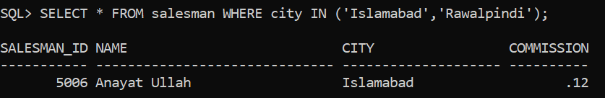
Task no 02:
Write a SQL statement to find the total purchase amount of all orders.
Output:
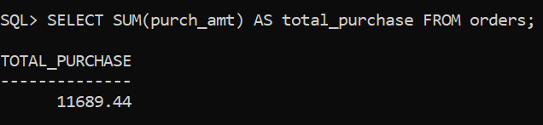
Task no 03:
Write a SQL statement to find the average purchase amount of all orders.
Output:
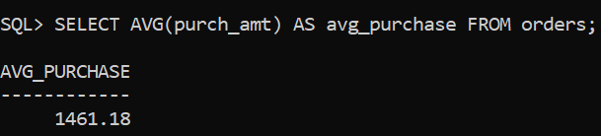
Task no 04:
Write a SQL statement to find the number of salesmen currently listing for all of their customers.
Output:
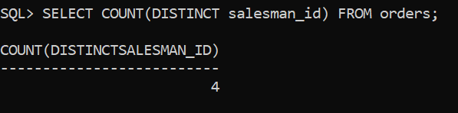
Task no 05:
Write a SQL statement know how many customer have listed their names.
Output:
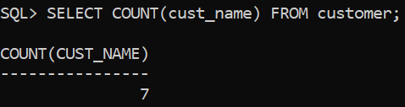
Task no 06:
Write a SQL statement find the number of customers who gets at least a gradation for his/her performance.
Output:
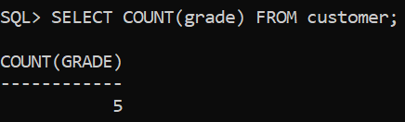
Task no 07:
Write a SQL statement to get the maximum purchase amount of all the orders.
Output:
